# HEBRON MOTORSPORT’S ELECTRICAL SYSTEMS REPORT

## ABSTRACT

Formula SAE is a global competition, which challenges students to design and build a formula-style racecar, which they then compete with in a series of dynamic and static events. Hebron Motorsports, the formula student team in Covenant University designed and is currently implementing their designs against the 2023 Formula Student competition in Silverstone UK. The electrical team considered three main systems to ensure durability and simplicity, being the first design ever attempted. They include; critical vehicle systems comprising engine control unit, sensors and actuators, the FSAE required safety system comprising safety shutdown buttons, switches, relay networks, break system plausibility device and circuit protection, electro-pneumatic shifting and additional designs comprising digitally controlled shifting, gear count display, neutral detector lights. Additionally, we considered compact wiring, purchasing cables of required length and compactness. We also ensured to employ standard terminations of cables to ensure system integrity. For the Safety Circuit Board, we ensured to incorporate appropriate redundancy in design that led us to print them as opposed to using perf boards whereas the shifting system circuit was implemented on a perf board. Schematics and detailed documentations were drafted on paper in order to help convey the information to people of other ’disciplines. Each system was prototyped on a bench or utilizing bred boards before they were implemented on the vehicle hence, separate wirings had to be provided.

## Table of Content

## Introduction

The Society of Automotive Engineers (SAE) is an international professional organization that regulates the automotive and aerospace industries. Various automotive arms are considered by this body, they are; traditional internal combustion drivetrains, electrical and hybrid systems. The body hosts various national and international collegiate competitions as part of its Collegiate Design Series. This competitions challenge students to build, design, manufacture and innovate on the current vehicle technology without specification on the type of vehicle.

Formula SAE is an arm of the SAE collegiate competition that focuses on the design and manufacture of small racing vehicles that can be used by any unprofessional racing enthusiast. The competition is designed to address all aspects of the creation of a formula style racecar. In addition to judging engineering designs, the competition also entails a number of other static events, they include; technical inspection, design presentation, cost presentation, and business presentation. These requires teams to apprehend the technicality and business aspect of their manufacture, as well as how to justify them. Teams compete in a number of events that are designed to score the their vehicle’s performance in various scenarios. Points are awarded all through the dynamic and static events that in turn result in the overall ranking of a team. However, a team cannot compete in any dynamic event without passing the technical inspection of their vehicle.

Formula Student UK is one of the competitions covered under the FSAE schedule, which the team intends to compete at in 2023. Hebron Motorsports was founded in 2014 in Covenant University with the aim of designing and manufacturing a mini racecar, which they planned to take to the FSUK competition. However, the team had a hard time sourcing out funds that would be used in the manufacture of their car, coupled with a few design problems. This eventually led to the teams’ comatose for about 5 years. In 2019, a few students decided to revive the team. They have competed in one static event and are on course to complete the manufacture of their first racecar for the formula student competition in Silverstone UK. A photograph of the participation in the FSAE competition is seen in the Figure 1.



Figure 1: FSAE competition attendees

For Hebron Motorsport’s first car design, we decided to focus on the general engineering principles thereby achieving a simple and reliable design. Our combustion vehicle comprises a Honda CBR 600 RR 2004 engine, a spool drive and all other normal systems.

The electronics system of this year’s design aimed to implement a reliable system via the utilization of the minimal number of components required for efficient running of our racecar. After designs were completed, detailed wirings had to be drafted in order to back each design claims. These circuits were simulated using a web environment (Fastlad.com). After simulation, wirings are provided for prototyping, this is usually performed on a bench or with a bred board, this wiring are stored to be used for another design or reused for the main wiring loom. For main wiring, emphasis was placed on apposite length for tidiness and reliability; reused wires were appropriately cleaned and labeled so as to aid the rapid identification of each.

PICTURE OF OUR CAR

### Aim and Objectives

The aim of our electrical systems design is to design, build, test and fully integrate an electronic system for Hebron Motorsports racecar to excel in all dynamic and static events in which they car will be tested.

### Project Justification

The design of the electrical control and monitoring system for our vehicle is composed of an engine control unit (ECU). This is relevant to control the engine management and auxiliary electrical systems for expanded sensor capability, control and communication options.

The standalone ECU can be regarded as the brain of the car as it controls all the major systems that make up the electrical design of our vehicle. The Honda CBR 600 RR electronic fuel injection EFI and ignition systems are primary components of the engine management system. In an EFI engine, fuel air mixture is delivered to the cylinders electronically by a system of sensors and pumps. The ignition system is the system that controls the spark supplied for the combustion of fuel air mixtures within the combustion cylinders; it comprises the ignition coils, sensors and voltage sources.

The ECU interfaces with the components of the engine management system listed; injectors, igniters, O2 sensors, fuel pump, radiator fan, cam and crank position sensors, temperature sensors and throttle position sensors etc. Due to the important function carried out by the ECU and EMS systems, care must be taken to ensure the selection of the most apposite systems to ensure functionality, reliability and performance. We will discuss more on this in latter chapters.

Auxiliary systems are minimal for our 2023 car due to our initial objective of simplicity and functionality. We however incorporated an electro-pneumatic shifting system, automatic gearshift push buttons and an on steering wheel gear display. The electro-pneumatic system utilizes compressed air to achieve sequential shifting between gears. In order to ensure reliability, we utilized push button switches connected directly from a 12 volts source, to control the solenoids that actuate the double acting cylinder used for gear shifting. Care has to be taken to ensure that there is not any leakage of air that renders the system useless, to this end, the location of critical components are a primary consideration. To assist the driver identify which gear he is currently on, a gear shift display was integrated to the steering wheel utilizing LED display and an Arduino for the counter control. A reed sensor is used as input into the Arduino that indicates that gearshift action has been performed.

The auxiliary system enhances the functionality of the existing standalone ECU; it also provides more information and control for the tuner, operator, or driver throughout the vehicle development process. The Figure below depicts the ECU used for this project due to its suitability when compared to the other stock ECUs.

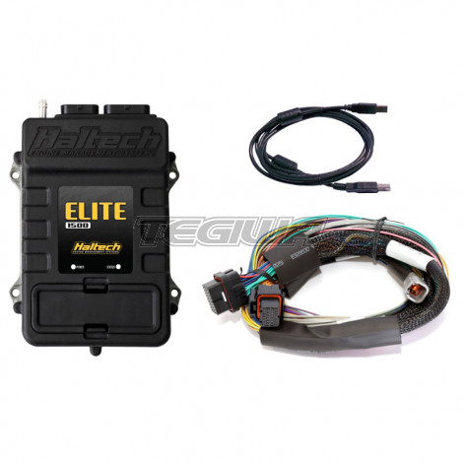

Figure 2: Haltech ECU

This project is outlines as follows: In Chapter 2, we will briefly explain all the sensors, components and devices to be utilized in our design, in Chapter 3, we will talk in detail about our designs and implementation, we will also talk about the challenges we encountered during the manufacture of both main and auxiliary systems, in Chapter 4, we will conclude on all the our design processes.

## Background

In this chapter, we aim to explain the concepts that govern the design of our electrical system, we also explain the sensors and devices in later section of this chapter. Most electrical systems are governed by fundamental principles that govern their behavior, regardless of how sophisticated they may seem. The engine control system and auxiliary systems are also complicated, but are a product of basic fundamental concepts. The Figure 3 provided below is a block diagram of the entire system, depicting both the main and auxiliary systems that are integrated together to achieve optimal functionality of the vehicle.

BLOCK DIAGRAM OF THE ENTIRE SYSTEMS

### ECU/EMS

There are generally two kinds of engines used for SAE competitions, the carburetor engine and the electronic fuel injection engine. The carburetor engine is a kind of engine in which the appropriation of the proper amount of air-fuel mix achieved by purely mechanical means whereas the EFI engine is one which utilizes computer control in the creating the proper air-fuel ratio by injecting a certain amount of fuel into oncoming air, and appropriate spark timing. Hebron motorsports utilized an EFI engine for the development of their 2023 vehicle.

### Carburetor Engine

A carburetor is a mechanical device for supplying a spark-ignition [engine](https://www.britannica.com/technology/engine-technology) with a mixture of [fuel](https://www.britannica.com/technology/fuel) and air. Components of carburetors usually include a storage chamber for liquid fuel, a choke, an [idling](https://www.britannica.com/dictionary/idling) (or slow-running) jet, a main jet, a venturi-shaped air-flow restriction, and an accelerator pump. A carbureted engine uses a carburetor. This device, is depicted in Figure 4, and is used for controlling the timing of ignition by mechanically controlling the amount fuel to be injected into a stream of oncoming air. The air entering the top of the carburetor represents the atmospheric air coming into the engine before being mixed with fuel. The air passes the choke valve and enters the Venturi, which lowers the air pressure and raises the velocity of the air causing the aerodynamic effects described in Bernoulli’s principle to syphoned fuel mixes with the fast moving air and vaporizes when the passage widens and the pressure lowers after the Venturi.

The air-fuel mixture then enters a cylinder through an intake valve located at the top of the cylinder head and is compressed by the piston. The distributer is then responsible for timing the high voltage spark from the ignition coil to ignite the fuel in the cylinder.

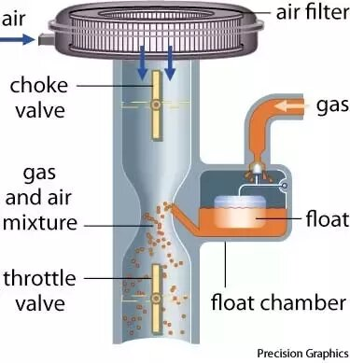

Figure 3: A simple carburetor

The Figure below is that of a distributor schematic. The distributor is placed at the top of a six-cylinder engine model with spark plug wires connecting the spark plugs as they are positioned on cylinders. Due to the numbering of cylinders, the distributer being mechanically connected to the camshaft establishes the ignition timing; this is what the cylinder valves are connected to, which in turn, establishes the timing of ignition based on the position of specially placed cams relative to cylinder head position.

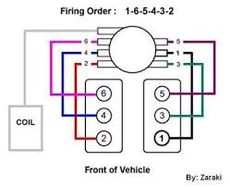

Figure 4: Distributor and wiring

All aspects of the air-to-fuel ratio and ignition timing in a carbureted engine are managed by mechanical systems, which have less tuning flexibility than an EFI engine. A carbureted engine's benefits include straightforward and dependable functioning without the need for complex electronic systems.

### EFI ENGINE

The objective of Electronic Fuel Injection System is to regulate and optimize the fuel/air ratio that enters a vehicle’s engine. Fuel injection has recently become the main fuel delivery system used in automotive petrol engines. An Electronic Fuel Injection engine utilizes a device known as the injector to spray the calculated amount of fuel into the intake air stream in order to create a proper air/fuel mix for combustion. The Electronic Fuel Injection System consists of electronic components and sensors. It has to be kept clean and well calibrated to boost the engine’s strength and efficiency and to cut down gas consumption. The carburetor is replaced with electronic actuated fuel injectors that use a solenoid to inject fuel, the distributor is replaced with single or multiple ignition coils that are controlled by the software that interfaces the ECU. The Figure below depicts an EFI configuration showing the connection between the ECU and required sensors and actuators of the EMS system in a loop known as the engine control loop.

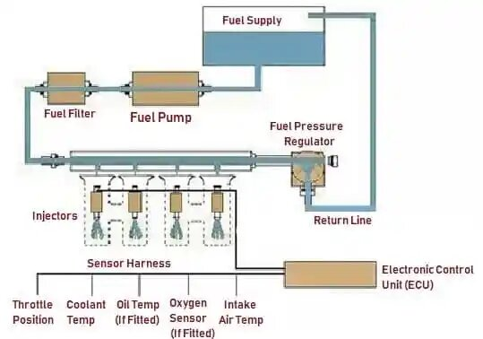

Figure 5: Electronic Fuel Injection System

In an EFI engine, atmospheric air enters the engine as it does in a carbureted engine, but instead of passing through a carburetor, the air passes through a throttle body, which acts to modulate the flow of the intake air system. The throttle body includes only the throttle valve, which can be butterfly or barrel in nature. As the intake air stream approaches the cylinders, the ECU obtains information from the throttle position sensor and other sensors; oxygen sensor, Manifold Absolute Pressure sensor and Intake Air Temperature, in a closed loop control system, to determine the amount of fuel to be injected into the air intake system or directly into the cylinders, depending on the type of injection system. This is used to create the appropriate air-fuel ratio for the cylinders. After mixing is completed, the air-fuel mixture enters the cylinder through an intake valve and is ignited at the correct time by the ECU controlled spark plugs and ignition coils.

Generally speaking, the ECU can be set to ignite the spark plugs at any point throughout an engine rotation. However, depending on the engine arrangement, the ECU may accept a mix of signals from the cam and/or crank position sensors in order to sense the position of the piston in the cylinder during rotation. When the ECU determines that the piston is in the proper position, a signal is delivered to the ignition coil, causing the spark plug in that cylinder to ignite the air-fuel mixture inside the cylinder. Compared to carbureted engines, the computer inside the ECU makes it possible to easily adjust engine characteristics like the air-fuel ratio and ignition timing, but it also needs very complex sensor systems to manage tuning and operation of the engine.

## Engine Management System Devices

The engine control loop is responsible for the electronical or automatic control of injection and ignition operations of a vehicle. An engine control loop consist of actuators, devices and sensors. A few of these devices and actuators are listed below. They receive outputs from the ECU and perform work required for the functioning of their respective systems. The ECU receives inputs from sensors that helps in the control of devices as well as informs the ECU on the appropriate time to send out signals to the actuators for work to be performed.

### Injectors

These are the actuators required to meter the fuel into the oncoming air stream. They contain controlled orifices that electronically open by signals from the ECU based on the information it recieves from sensors all around the car. They are the end of the fuel system, which starts from the fuel tank, to fuel pump and fuel rails then to the injector. There are various types of injection systems; direct injection, semi-direct fuel injection system and throttle body injection system. The CBR600 RR engine uses a direct injection system for its primary injection system and a throttle body injection for a secondary injection system. We however discarded the secondary injection system, to utilize only the primary injectors in our design. We utilized the stock injectors because a change in injector would require adaptations to be made on the injector ports, which we hope to avoid.

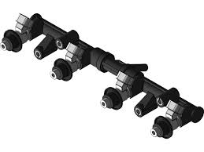

Figure 6: INJECTOR RAIL

### Fuel Pump

Fuel pumps are essential components to the electronic fuel injection system as they aid in the maintenance of high-pressure fuel on the fuel lines to be injected into the mixture by the injector. They are either internal or external pumps, mechanical or electronic pumps. For our 2023 vehicle, we utilized a Walbro GSL391 inline fuel pump.

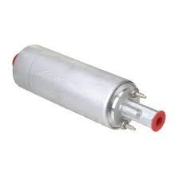

Figure 7: Fuel Pump

### Ignition Coils

The ignition coil is necessary in order to generate a spark and therefore initiate combustion in the combustion chamber of the engine. The ECU is compatible with a number of ignition modules but does not have an onboard ignition module. In the case of most modern vehicles, ignition module that drive the ignition coil are built into a single unit minimizing space and creating an all-around easier implementation of the components. The Haltech 1500 ECU provides a 12-volt supply, sensor ground, and a signaling wire to the ignition module and coil. When a small signal is sent from the ECU to the module, the coil is used as a transformer in order to build voltage far beyond that capable of being provided by the battery. Since the signal sent from the ECU is very small, sometimes an external ignition module is required to amplify the signal before being sent to the stick on coil ignition system. We included a Haltech High Power Igniter Module.

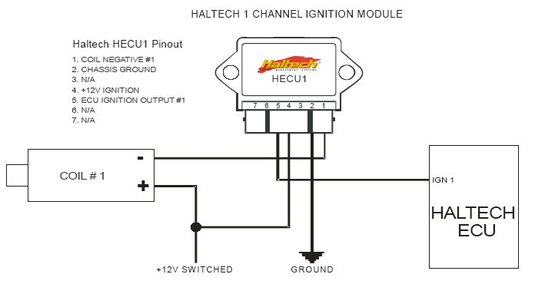

Figure 8: ECU TO COIL WIRING WITH HPI IGNITION MODULE

### Throttle body

The throttle body chosen was a Jenvey 32mm throttle body that is designed for the intent of OEM applications. The throttle body uses proprietary automotive electrical connectors. Using an OEM throttle body has the benefit of being easily configurable and also passes all FSAE rules for competiton without further technical evaluation from competition rule makers due to the industry standards in place that the product used already abides by. Wiring the throttle body is done as indicated in the specification pamphlet that comes with the throttle body, an image of the technical drawing of the throttle body is provided below. Once wiring is completed, the ECU is able to self-calibrate the unit by actuating the throttle plate motor and reading the sensors to develop a curve as to how the signals react to the input.

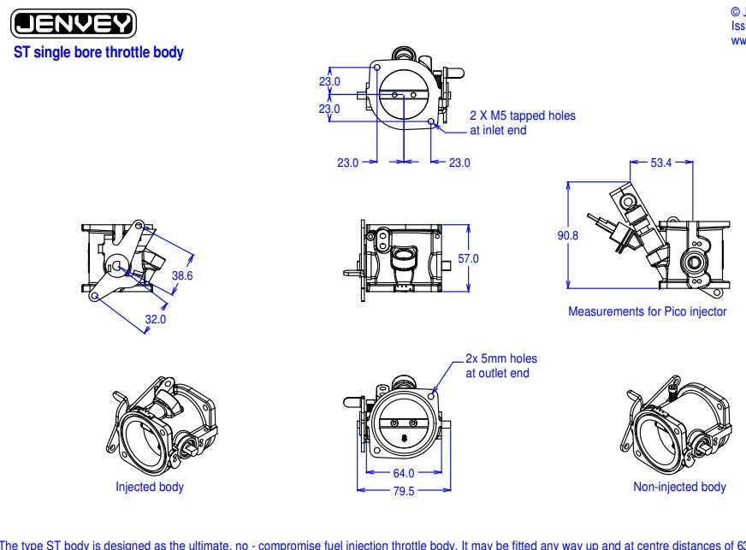

Figure 9: MECHANICAL SPECIFICATION OF THROTTLE BODY

### ECU

The Engine Control Unit is the center of the electrical system for any vehicle management system. Designed to be user friendly and achieve a high level of functionality, the Haltech Elite 1500 ECU that was chosen for our 2023 car since it has the functionality to run a variety of engines up to 8 cylinders and supports a modern drive-by-wire throttle control which may be utilized for our 2024 car. This ECU allows for a variety of generic input output as well as basic functions that can be configured in a graphical user interface. From the perspective of competition, the benefits of this ECU are that it eliminates less reliable mechanical systems while providing the team with the ability to easily configure, troubleshoot, and make adjustments to the vehicle.

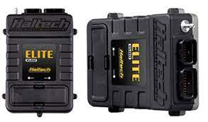

Figure 10: Haltech Elite 1500 ECU

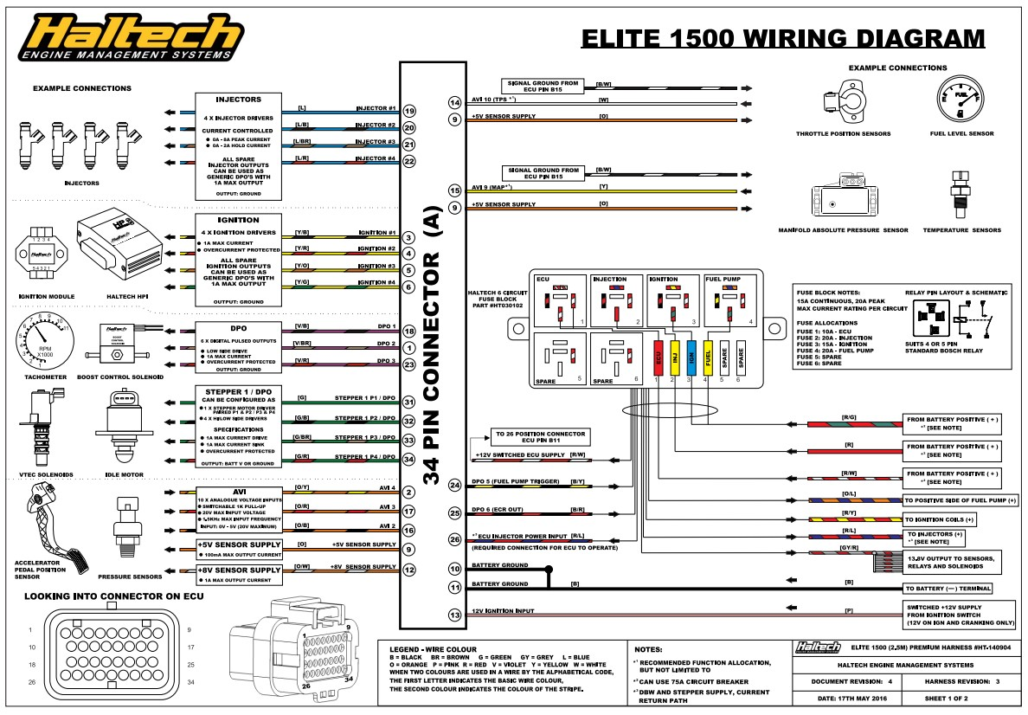

Figure 11: haltech wire diagram page 1

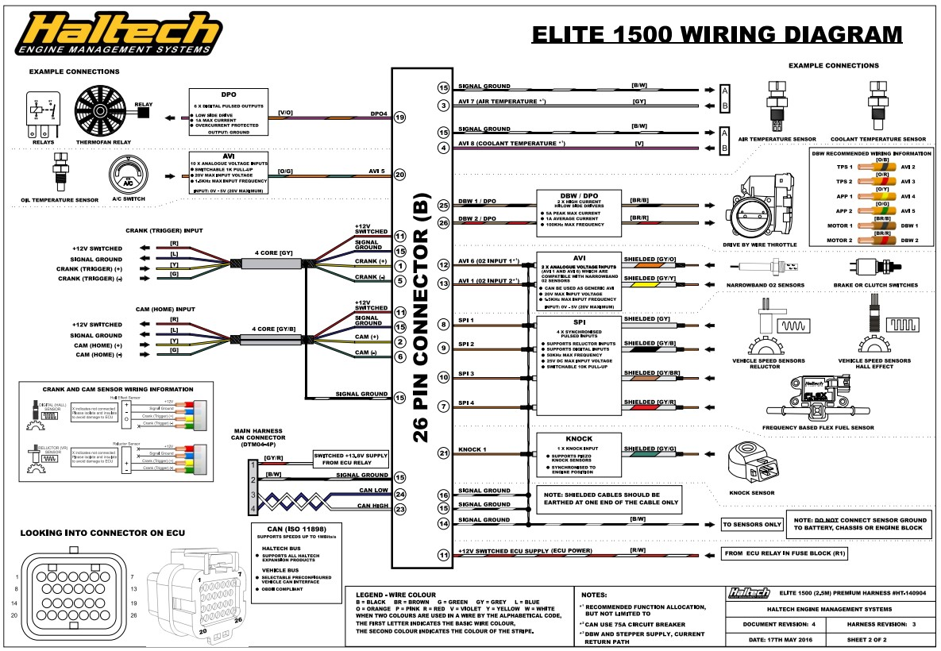

Figure 12: Haltech Elite 1500 wire diagram 2

The tuning system of the Haltech is a self-learning system that relies heavily on the oxygen sensor in the car. Assuming proper intake design and injector placement, this means a rough tune of the fuel and air into the vehicle will be self-adjusted by the ECU in order to increase the power and torque potential of the vehicle. All of this functionality is built into the ECU and requires no coding or electrical engineering expertise from the team. The extent of the design for the ECU first entails designing the electrical system to properly meet the needs of the sensors and actuators chosen, then using the ECU software in order to properly specify the functionality that is intended to be used, and finally wiring of all the electrical components that are connected to the ECU. In the case of resistive sensors and those that require calibration, the Haltech Elite 1500 ECU allows the team to input resistance curves and sensing equivalent of these values in addition to the calibration software that coordinates components in the device to function properly. The ECU also provides a suggested wiring diagram that is robust and will allow almost any engine to be operated from the management system.

## Engine Management System Sensors

The engine management system is a closed loop system comprising of sensors, actuators and a controller in form of a mini computer. The sensors discussed in this section are necessary to control electronic injection of the fuel and electronic ignition via the use of ignition coils.

### Manifold Absolute Pressure Sensor

The manifold absolute pressure sensor (MAP) serves the purpose of allowing the engine management system to properly interpret the amount of air that is being taken into the engine by measuring the vacuum or negative pressure inside the intake. It has a direct impact on how the engine operates responding to various conditions. The calibration of this sensor is necessary in order to ensure appropriate functionality of the sensor during operations, this calibration is done with reference to the datasheet. This datasheet table corresponds to voltages that can then be interpreted by the Haltech ECU. For our 2023 vehicle, we went with the Honda CBR 600 RR stock manifold absolute pressure sensor because it integrates perfectly into the system and will function, as the engine requires.

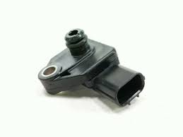

Figure 13: Honda CBR 600 MAP sensor

### Inlet Temperature Sensor

The inlet air temperature sensor (IAT) is required to assess the temperature of incoming air in order to calculate the quantity of air due to the change in the density of the air. As the density of air changes, the quantity of air present in the same volume of air varies as the air has the quality of expansion hence a temperature sensor is required. For our design we utilized the stock sensor that comes with the bike, we however adapted our 3D printed intake to fit it.

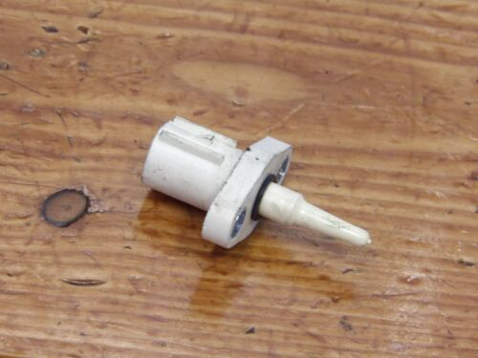

Figure 14: IAT Sensor

### Oxygen Sensor

For efficient tuning capabilities, an oxygen sensor is to be included into the engine control loop. There are generally two kinds of oxygen sensors included to the engine control loop; the narrowband O2 sensor and the wideband O2 sensor. The narrowband has a limited sensitivity range as compared with the wideband O2 sensor however, the Haltech 1500 ECU will require an external wideband O2 controller to aid proper interpretation of the signal by the ECU. We went for the narrowband O2 sensor for the development of our 2023 vehicle because it can be easily integrated into our engine control loop without the need of external devices.

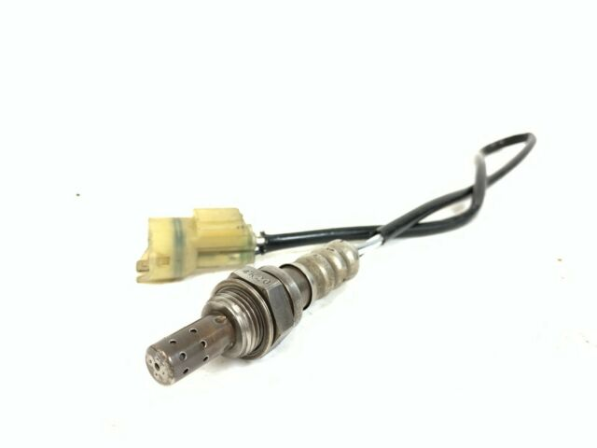

Figure 15: NARROWBAND O2 SENSOR

### Throttle Positon Sensor

Throttle position is required by the ECU for appropriately calculating the required fuel to be injected into an oncoming air stream. The throttle position value used in calculations is represented as a percentage. This percentage value correlates to how far open the throttle valve is, with 0% representing a completely closed throttle valve and 100% representing a completely opened throttle valve. A throttle position sensor (TPS) is required to measure the position of the throttle valve. The TPS consists of a potentiometer and a return spring so that an analog voltage is sent to the ECU that is directly proportional to the position of the valve. The sensor is calibrated by configuring the analog voltage values corresponding to a closed throttle and open throttle within the ECU software.

### Crank and Positon Sensor

To time fuel injection and ignition accurately, the ECU must be able to detect the location of each piston in the engine. The ECU requires either a crank sensor or a cam sensor to track the position of the crankshaft or camshaft, respectively, in order to track the position of the pistons. Both kinds of sensors are sometimes used together in engine layouts to monitor piston position. The crankshaft connects all pistons together and is the main drive axle for the engine that transfers power to the transmission and the camshaft sits on top of the cylinders with specially positioned cams that actuates the intake and exhaust valves for each cylinder. Either a variable reluctance sensor of a Hall Effect sensor may be used for the crank and cam sensors depending on cost and operating conditions.

Both types of sensors work by detecting the motion of a toothed gear in front of the sensor but the method of acquiring a signal itself is different for variable reluctance and Hall Effect sensors. A variable reluctance sensor is constructed of a magnetized pole that is surrounded by a coil of wire and a sinusoidal signal is induced in the coil of wire when the magnetized pole moves due to the rotation of the toothed gear. As a tooth moves in front of the sensor, the magnetized pole is attracted to it and moves closer to the gear. The magnetic pole returns to its initial position when the tooth passes, producing the sinusoidal motion required to produce a voltage on the coil of wire encircling the pole. Due to their straightforward design and propensity to resist higher temperatures, variable reluctance sensors are often less expensive than Hall Effect sensors. This makes them ideal for usage in hot areas of engines.

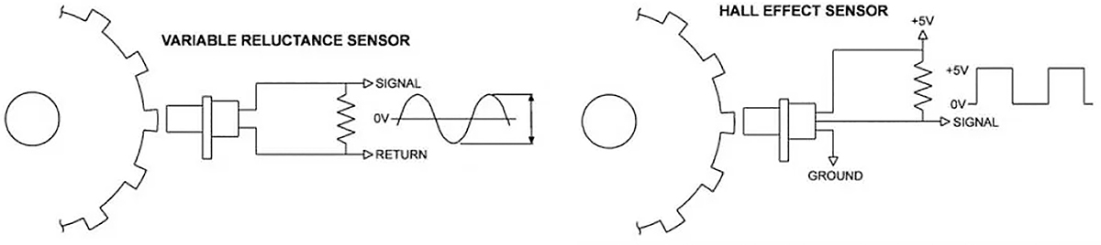

Figure 16: variable reluctance and hall effect sensor

Based on the location of a toothed gear in front of the sensor, a conventional automotive Hall Effect sensor generates a crisp square wave signal. As opposed to Hall Effect sensors, which are more complex than variable reluctance sensors and typically more expensive, square wave signals require less signal processing in the ECU.

### Coolant Temperature Sensor

Coolant temperature sensors usually depend on the casting of the engine block, it is usually a normal practice for formula student teams to use the stock temperature sensor so as not to alter the placement of the sensor. The resistance curve has to be extrapolated in order to build a curve for the Haltech software. We utilized the Honda CBR 600RR 2004 model’s stock coolant temperature sensor for our application and had to go through a sequence of process to enable the ECU properly read values from it, this will be documented in chapter 4.

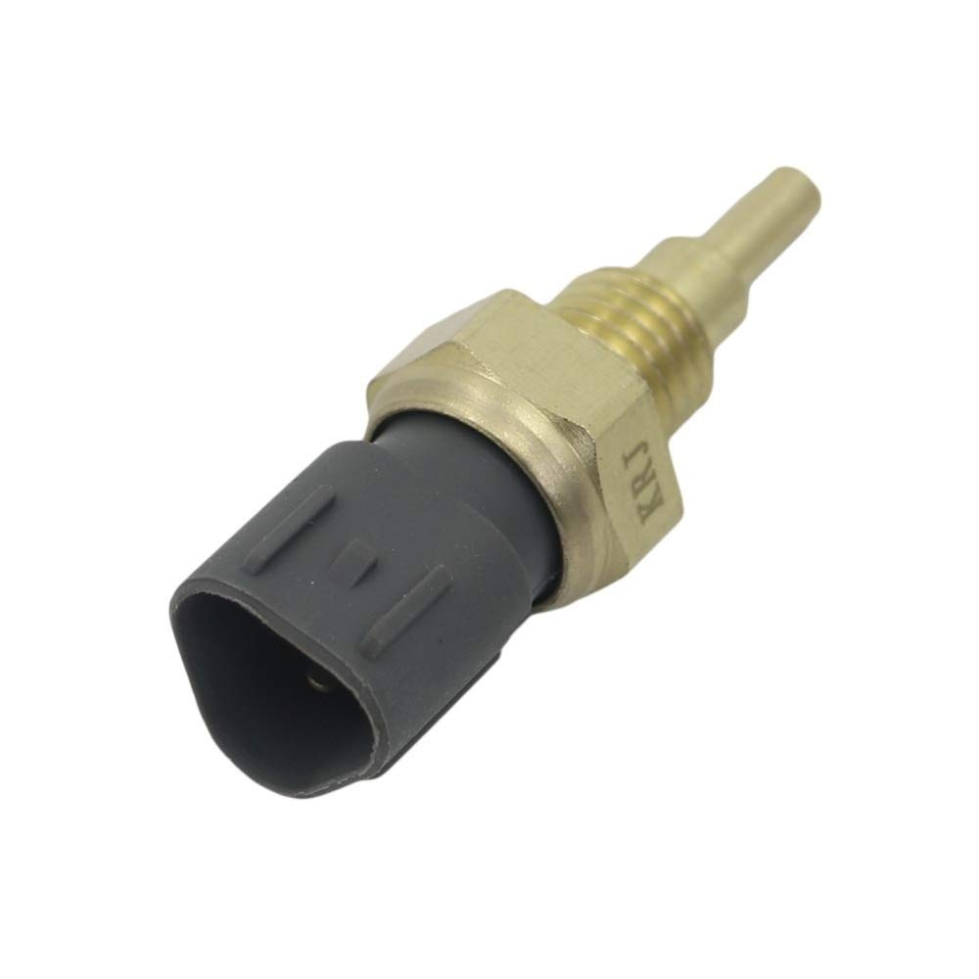

Figure 17: coolant temperature sensor

## Auxiliary components

The auxiliary components are the components and sensors that are not typically managed by the ECU and are not integral to the engine management system. All the components included here are those either required by the formula student rulebook or generally required in order to achieve smooth functionality of our vehicle.

### Arduino Mega 2560

The Arduino controller was planned to be utilized for the control of our gear shifting system and gear display system utilizing the ATmega 2560 chip, the specifications are as follows; The ATmega2560 provides the following features: 256K bytes of In-System Programmable Flash with Read-While-Write capabilities, 4Kbytes EEPROM, 8Kbytes SRAM, 54 general purpose I/O lines, 32 general purpose working registers, Real Time Counter (RTC), six flexible Timer/Counters with compare modes and PWM, four USARTs, a byte oriented 2-wire Serial Interface, a 16-channel, 10-bit ADC with optional differential input stage with programmable gain, programmable Watchdog Timer with Internal Oscillator, an SPI serial port, IEEE® std. 1149.1 compliant JTAG test interface, also used for accessing the On-chip Debug system and programming and six software selectable power saving modes. The Idle mode stops the CPU while allowing the SRAM, Timer/Counters, SPI port, and interrupt system to continue functioning. The Power-down mode saves the register contents but freezes the Oscillator, disabling all other chip functions until the next interrupt or Hardware Reset. In Power-save mode, the asynchronous timer continues to run, allowing the user to maintain a timer base while the rest of the device is sleeping. The ADC Noise Reduction mode stops the CPU and all I/O modules except Asynchronous Timer and ADC, to minimize switching noise during ADC conversions. In Standby mode, the Crystal/Resonator Oscillator is running while the rest of the device is sleeping. This allows very fast start-up combined with low power consumption. In Extended Standby mode, both the main Oscillator and the Asynchronous Timer continue to run.

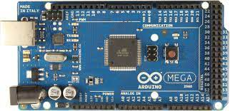

Figure 18: ARDUINO BOARD

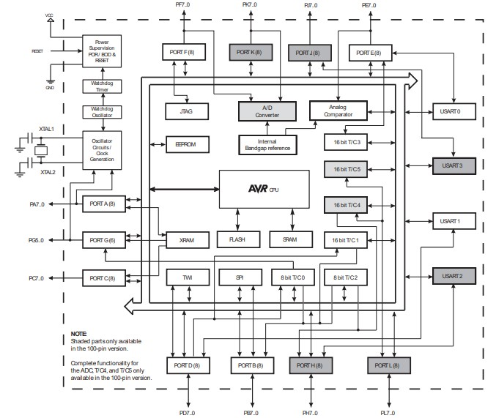

Figure 19: ARDUINO MEGA 2560 BLOCK DIAGRAM

### Brake Pressure Sensor

One of the inputs to the ECU is the brake pressure sensor, this assist the ECU control various functionality this input is also required by the safety system, in order to trigger the shutdown system. The brake pressure sensor is connected to the brake hydraulic lines, in a system of primary and secondary brake lines; for the front and rear wheel. The primary line brake pressure sensor is connected to the brake system plausibility device while the secondary is connected to the ECU.

### Oil Temperature Sensor

An oil temperature sensor is used by the ECU to track engine oil temperature. This sensor measures the temperature of the engine oil using a sealed thermocouple in contact with oil in the engine's crankcase. When adjusting the radiator fan speed, the ECU also takes into account the coolant and oil temperatures. Data on oil temperature is not regarded as crucial to engine operation.

### Fuel Pressure Sensor

The fuel line is primarily important as it is essential for the supply of high pressure fuel to the injectors. It becomes essential to monitor the pressure of the fuel at the mount of the injector as the pressure will determine the mass of fuel injected for a specific time duration. The fuel pressure sensor plays this role, as it is fed into the ECU, the ECU then uses this value to ascertain the duration of time the injector valve opens in order to achieve a certain amount of fuel injected into the stream of oncoming air.

### Crash sensor

An inertia switch is included into the safety system to ensure that rapid motion of the vehicle in any direction causes a shutdown of the electrical system. The shutdown circuit must be triggered by any omnidirectional acceleration of greater than or equal to 8gs. It is advisable that teams utilize the sensatta resettable crash sensor as it meets all these requirements.

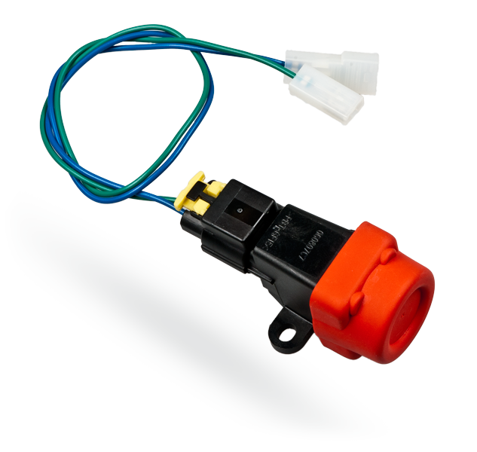

Figure 20: INERTIA SWITCH

### Neutral Indicator Sensor

The purpose of this sensor is to tell when the transmission is in neutral for electric start purposes. The system is design so that the electric starter is not allowed to engage unless the bike is in neutral, preventing transmission and starter damage. The neutral indicator sensor from the Honda CBR 600 RR engine is screw able to the engine casing where it is earthed.

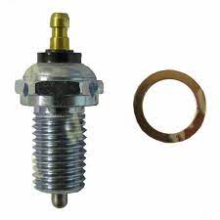

Figure 21: Neutral Light Switch

## METHODOLOGY

In this section, we aim to define our design goals in detail, and how they translated to the spirit, and mode of operation of the team. Our team consists of various sub-teams with each sub-team requiring that little electronics be integrated into their mechanical system for additional functionality and automation. We have a structure in place for the design and wiring of hardware components and also for software integration. Our testing and implementation strategy is also discussed.

### Project Goals

The goal of this project was to design and build an electrical monitoring and control system for the Hebron Motorsports Formula SAE vehicle for the following purposes:

1. To design and implement an electrical system, with minimal electronics, that is reliable and functional.
2. To design an automatic shifting system that reduces the time taken for shifting action and to minimize the skill experience needed to drive the vehicle.
3. To achieve reasonable engine tuning with the Haltech Elite 1500 ECU.

Hebron Motorsports is a new team and hence has limited project management experience. The team comprises 15 people of which only one is in charge of the entire electronics design. I began by gathering all relevant resources that I felt were necessary in order arrive at an overview knowledge of what the design of an electronics system entails. The information obtained from this study was integral to deciding what systems to be included into our electronic systems design, in line with our aim.

Upon selection of the systems to be included into the design, an analysis of all the possible design choices that can be implemented for each sub-system had to be conducted to aid in the selection of the most appropriate due to various constraints; complexity, cost, manufacture lead time, shipping and custom cost.

After the selection of the appropriate design technique to be employed applied research had to be conducted with the aim of completing the design by creating a design structure and developing their initial wiring diagrams. Each of the wiring diagrams are simulated using specific software packages that aid in identifying faulty connections, we utilized *fastlad.com* an online circuit simulator for our circuits.

The prototyping stage is where we physically test our circuitry on a smaller scale to ensure it performs appropriately. This stage confirms that the software implementation, hardware design and code performs as expected, any circuitry problem encountered after this point is solely and implementation problem.

In the implementation phase problems not noticed during designs are encountered, however these problems are not design or programming related, they are a result of improper and non-rigid connections and faulty devices. These problems are the hardest to diagnose and the costliest to solve.

Challenges that occur during the implementation phase are continuously corrected during testing. A design lifecycle flow chart is provided in the figure below.

### Team Operation Structure

The team originally began with about 30 member divided into 4 sub sections namely; Electrical, Engine, Chassis and Suspension. Because the team was just revived from coma, nobody had any experience on running a team and little progress were made after tasks were distributed; this was also due to that members were relatively new to most of the fields, and there was a lack of an adequate feedback system.

As time went by, members that weren’t as motivated left the team, leaving only 5 motivated members. Each person out of this 5 were then tasked with designing one entire system of the 4, with one serving as the team leader and the interface between multiple system.

The team’s manufacture plan was a sequential one that required feedback only at the end of each assigned objectives. Teammates in charge of subsystems were then charged with defining tasks to meet the assigned objectives. At the end of an objective duration the tasks define by teammates, in an attempt to meet the objectives, are assessed on the basis of tasks completed or task complexity; this is because teammembers are all relatively new to their subsystems and hence cannot assert the complexity of any task until extensive research has been invested by the assigned teammate.

Software required are also discovered during this extensive research period. We then request for licenses and source learning materials that will aid in efficient design of the specified system.

After designs are completed, they are assessed on the basis of design for manufacture, to ensure that components chosen are readily available and can be easily sourced afterwards, a manufacture and purchase list is created with all appropriate specifications to aid in the purchase of the exact item as specified on the purchase list.

After all components arrive, the team crosschecks to ensure that they are exactly as specified, if not, the item is returned.

All purchased items are taken to the assembly location where prototyping and implementation takes place. Afterwards, they are tested to ensure that the perform as required.

### Hardware Design

We limit hardware in this section to circuit boards. The hardware components designed and fabricated are the brake system plausibility device and the shifting system printed circuit board. For the fabrication of printed circuit boards, the primary decision is whether the board is to be made in house or by a fabrication company. This decision is usually influenced by the purpose of the board. I designed 2 printed circuit boards for our 2023 vehicle; the Break System Plausibility Device and the Shifting system board. Due to the design requirements of the BSPD, we sent it to be manufactured under close quality control by a fabrication company while the shifting board was designed in-house using a perf board and through-hole components.

The designs begin with development of the internal wiring of the board or the board schematic. This is usually a product of the consolidation of all research and design study. The schematic determines the entire characteristics of the board. Designing a good schematic will require the utilization of a reference design, this is relevant as considerations were made regarding safety and redundancy that could just be transferred to the intended design. I came up with a schematic for each of the Printed circuit boards I intended to design.

For sophisticated boards, a PCB design software will have to be used. After the schematic has been designed using this software, the 3 dimensional board has to be configured with the required components selected and spacing specified. This view represents how the finished PCB will appear. Additionally, we can specify the number of routing layers we want so as not to congest the board.

For boards designed with software, the CAM files are generated, these are the files that are requested by the fabricator while for boards made in-house, the schematic is implemented on a perf board by the team.

### Software Design

Two software packages were integral to the tuning and implementation of the electrical system; the Arduino software and the Haltech tuning softwares. The team had to learn to program the Arduino in order to setup the shifting system, we had to learn a bit about engine tuning and how to navigate the software in a bid to achieve a proper engine tune.

Arduino

The Arduino microcontroller is used as the auxiliary controller that controls the gearshift counter of the shifting system. It receives inputs from the required sensors and outputs count values. A program has to be written for this operation to be performed. The Arduino provides an environment where programs can be written, this environment is typically a C++ environment.

The Arduino software provides access to sample codes that can guide the programmer in writing newer programs.

In order for programs to be written, we write down an algorithm of the operations of the system then translate the algorithm to Arduino sketch, to be uploaded into the Arduino board.

Haltech Tuning Software

### Testing and implementation

## ENGINEERING DESIGN

### ECU and Programing

Overview

Design

Implementation

Challenges

### Brake System Plausibility Design

The brake system plausibility device is a part of the safety requirement for any FSAE vehicle. The rule can be found in T11.6. it says ‘The BSPD must be a standalone non-programmable circuit, that must open the shutdown circuit when hard braking occurs (Hard braking is denoted by a pressure 30 bars) and the throttle position is more than 25% over the idle position’ it must be designed with high integrity as it is tested at the event to ensure compliance with the given rules.

The BSPD was the last electrical sub-system to be designed by our team because this is our first design and we did not know that we needed to design a board. Our initial plan was to utilize a microcontroller and program it to the requirements however, we were informed that that wasn’t allowed so we had to begin making plans to build the board. We had to determine how the board was going to be built, if we were going to make it in-house using a perf board or send the board to a PCB manufacturer. Considerations on board reliability and integrity were made, this assisted us decide to print the board instead of making it in-house using a perf board and through-hole components.

For the board design, we required a printed circuit board design software, we then contacted other teams and they recommended a few software choices; Proteus, Eagle and Altium designer software. Our team requested for a license from Altium designer and obtained a five seat online license. Upon securing the license, the learning commenced.

The learning curve for the BSPD design was rapid as team members had to take a course on digital logic and programming by Prof Brock Lameres of Michigan State University in order to acquire the fundamental knowledge required for the board design. We then took a course on Altium designer software so we could learn to navigate the software to achieve our desired designs.

After all the courses, we still had issues incorporating the required conditions into a functional board. We initially planned to use flip-flops and a timer to achieve the delay conditions, the gates to achieve the combinational logic require to combine the results from the sensors as they have been converted from analog signals to digital signals by a comparator operational amplifier. We eventually utilized a solid-state relay and additional gates to achieve the time delay, for the combinational logic, we utilized three separate gates each for the separate sensors in order to improve the safety and reliability of the board.

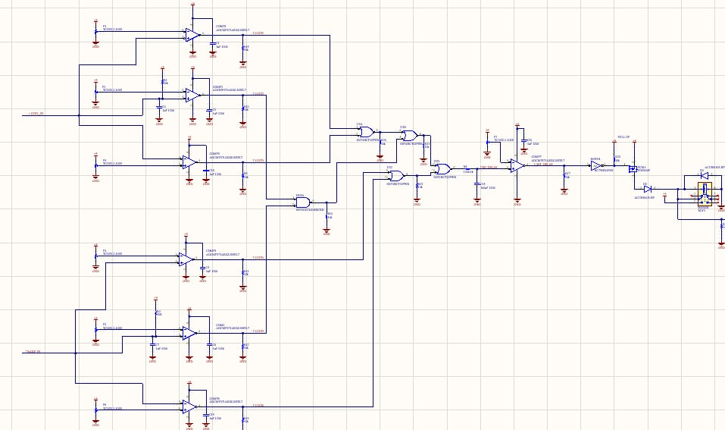

Figure : BSPD schematics

Upon completion of the schematics, the board is designed just as it will look in real life, components are dragged and placed on a plane board, the amount of routing layers are configured in bid to improve the arrangement of components or reduce the board size. For components that are not available in the software library, their footprints have to be built in another window before it is incorporated into the board assembly: The design will require intermittent reference to the datasheet of the component, where the part is dimensioned. This is important as during actual fabrication, the Pads created must match the pinout of the components otherwise the board will not work. Components will have to be specified as DNPs if the team intends to mount some components by themselves. The team will have to decide if components will be surface mount technology or through hole technology, this will influence the size and routing of the board. After the board has been completed, Altium software informs on all possible mounting and routing errors, this will have to be corrected before CAM files can be created.

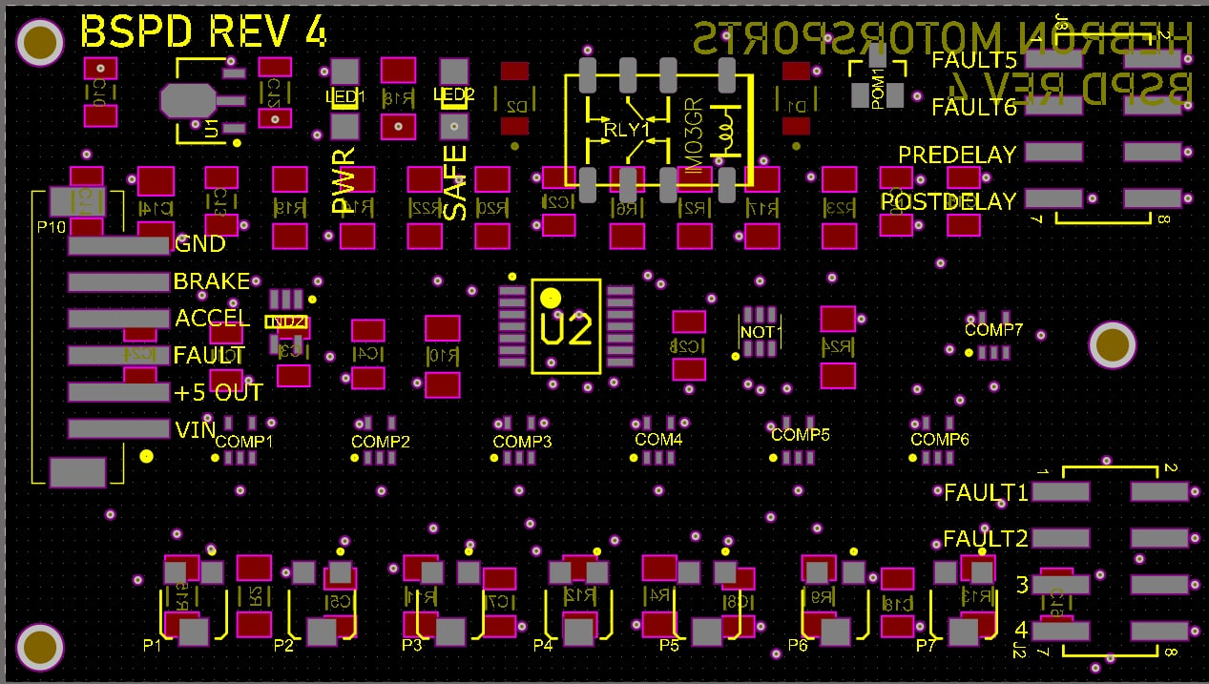

Figure : two dimensional board

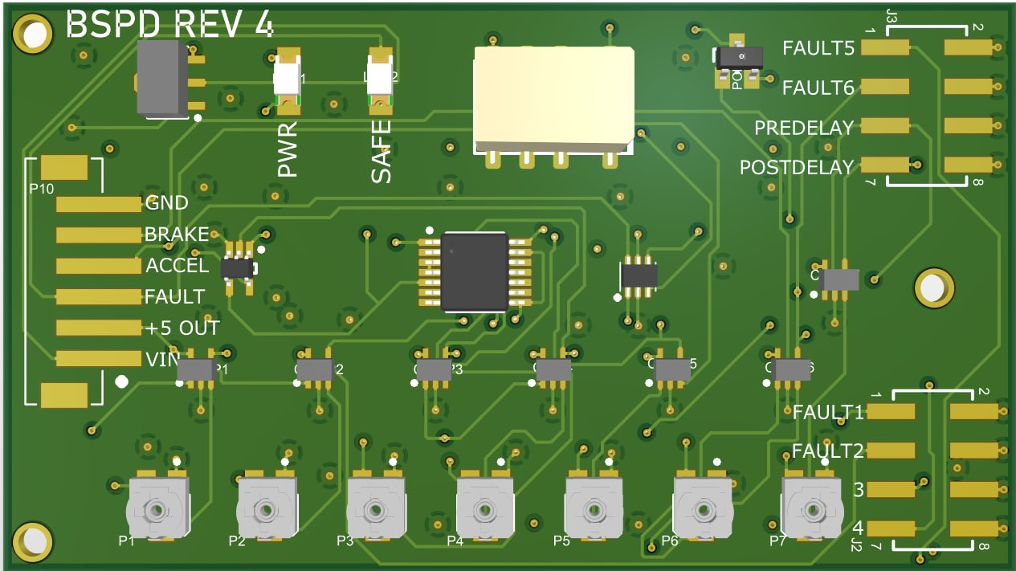

Figure : three dimensional board

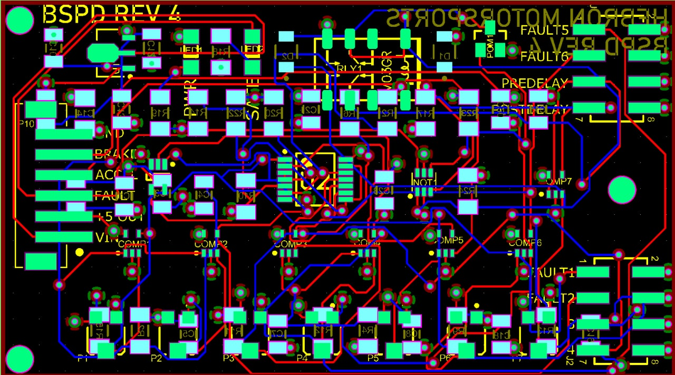

Figure : BOARD CAM

After completing the board design, the team had to find a nearby fabricator. However, the only fabricators were in the United States and China. Companies in the had a high minimum order quantity so we weren’t able to use them, we opted to patronize a company in china ‘pcbcart.com’ we had to generate all required CAM files for the board manufacture to commence. Series of engineering questions were sent to the team during fabrication in order to confirm some design choices. Pictures of the completed board can be found below.

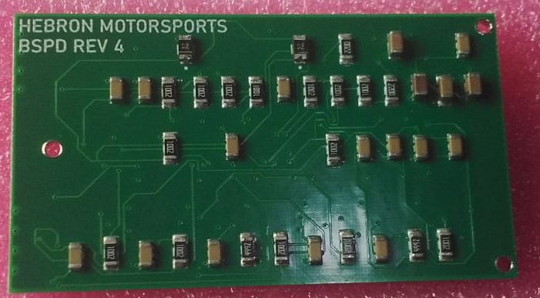

Figure : PYHSICAL BOARD FRONT VIEW

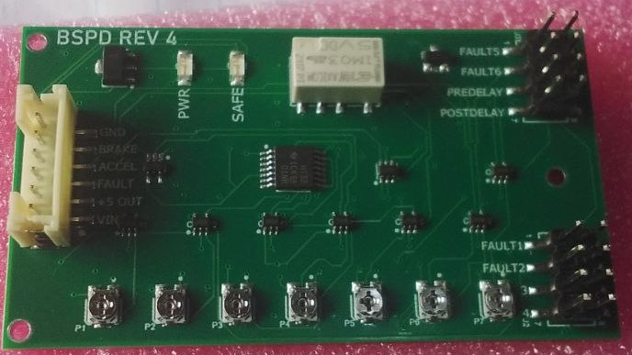

Figure : PYHSICAL BOARD BACK VIEW

#### Challenges

Our foremost challenge was the lack of the knowledge required to design an analog standalone printed circuit board. After assessing the design requirement, I had to find the course that covered all relevant knowledge. This course had about 140 videos that took us an average of 1 month to complete before going to the next course on Altium Designer Software. Upon completion of the courses, I still could not design a functional board. After much considerations I found a reference design on ‘github.com’ that guided me in designing a safe, functional and reliable board.

### Safety System

The safety system comprises the shutdown buttons, the low voltage master switch (LVMS), the inertia switch, the brake over trail switch and the brake system plausibility device. Each of these components can shut down the vehicle operations if specific conditions that trigger their actions are met. The Figure below shows the arrangement of the shutdown circuit as stipulated by FSAE

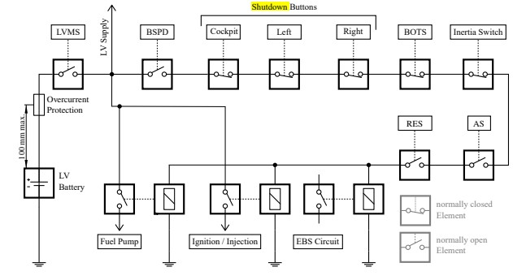

Figure : SHUTDOWN CIRCUIT CONFIGURATION

We incorporated all the required components to our safety system, utilizing mechanical relays on the main line, each component is connected to the relay trigger pending on the required open condition. Our team designed a safety system in line with the regulations and incorporated it into the general car wiring. The Figure below depicts the safety system wiring design.

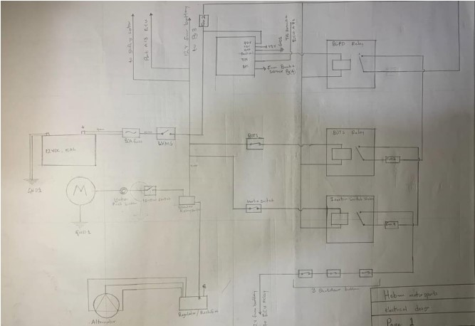

Figure : SAFETY SYSTEM DESIGN

Implementation

Challenges

### Engine Management System

The EMS system comprises fuel injection and ignition systems, which are controlled by the engine control unit (ECU), sensors and actuators. The EMS system is the primary system to an electronic fuel injection EFI engine.

We utilized the Haltech Elite 1500 ECU for the control of our and ignition systems, this was connected to a High Power Igniter module before being connected to the stick coils. The signal to the injectors came directly from the ECU, as a product of inputs from sensors that assist the ECU in accurately timing injection and ignition.

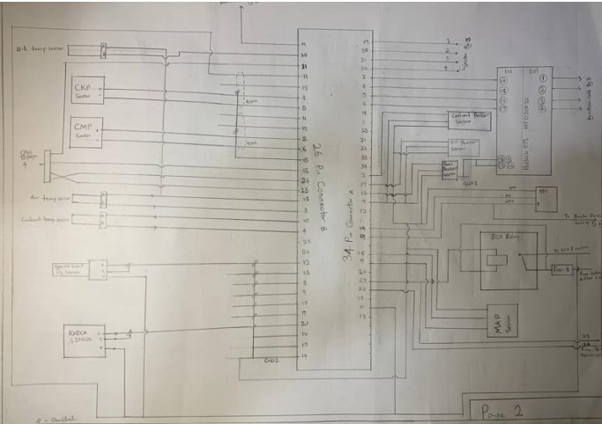

Figure : ECU WIRING TO SENSORS

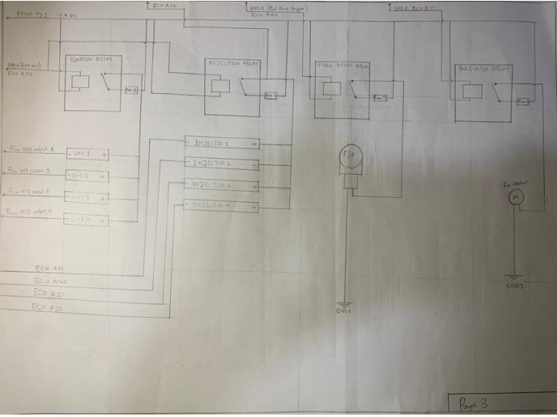

Figure : ECU WIRING TO INJECTORS AND COILS

Implementation

Challenges

### Coolant and Fuel System

The fuel and cooling systems are primarily mechanical systems, with the addition of a few electronics components for the automatic control of their operations. The fuel line typically has a fuel pump and fuel pressure sensor, the fuel pump is controlled by the ECU, with power coming directly from the battery. The fuel pressure sensor supplies the ECU with additional information that aids the appropriate control of the fuel pump.

The radiator fan and coolant temperature sensor are the electronic components in the cooling line, they work hand in hand. As the temperature of the cooling fluid is sensed and sent to the ECU, the ECU appropriately regulates the fan in order to maintain a certain temperature.

Implementation

Challenges

### Charging System

The charging system comprises the stator and regulator; these are connected to the battery. After the power in the battery is drained, the rotation of the crankshaft is converted to electricity by the stator attached to it. The electricity produced is AC in nature and will have to be converted to DC before it can be used to charge the battery. The regulator or rectifier addresses this, it is a device that converts alternating current to direct current that can be used in charging the battery.

Implementation

Challenges

### Shifting and Steering Wheel

Gear shifting is important to combustion vehicles because their engines require the change of gear ratios in order to increase the speed or torque at constant power. The gearbox is that which serves to make speed and torque tradeoff at a constant power output of the engine. It consists of a collection of gears of different sizes that function to control the speed of the engine at a constant power output.

In order for the tires to overcome the friction drag that exists when it intends to move from an idle position, the wheels must have sufficient torque. Because power relates with torque and rotational speed by the formula to increase the torque at a constant power means a reduction in the rotational speed. When the vehicle is in motion, less torque is required due to that dynamic friction is less than static friction, hence the torque can be reduced in order to achieve higher speeds. In an automobile, early gears have higher torque and low rotational speed, while later gears have lower torque and higher speeds.

There are various methods utilized for the change of gears in automobiles however due to the fact that the engine utilized by most formula student teams have a sequential gear arrangement, the most prominent methods employed are; mechanical shifting using a mechanism, electronic shifting using motors, and electro-pneumatic shifting. For the design of our 2023 car, we designed an electro-pneumatic gear shifting system.

Our electro-pneumatic shifting system utilizes compressed air connected to a double actuating cylinder in order to achieve shifting operation.

##### Design

The design of our shifting system began by our team, selecting the kind of shifting system that helps foster our overall design goals of reliability and functionality. After careful consideration of the available methods, we opted for the electro-pneumatic gear shifting method. The next step was to find materials, and contact teams that had done similar designs. We found a few published resources and contacted their authors in order to get a general idea of the task at hand. After much questions, we began designs by drafting the circuit diagram for the entire system and the PCB, then the programming of the microcontroller used.

##### FUNCTIONALITY

Our design begins from the pressurized air storage tank that supplies pressurized air required for a shift action. The tank is connected to the double acting cylinder by a network of pneumatic lines and pneumatic fittings. There is a 5 port 3 position (pressure return on normal) type solenoid valve; this returns to a state of no pressure when power is cutoff.

The solenoid valve is connected from the battery, through an N channel MOSFET, the MOSFET is controlled by 5volts from the push button switches that initiates the shifting action.

The position of the gear is important to the driver as knowing what gear the car is in aids in proper control and appropriation of actions. A display was provided on the steering wheel along with the shift buttons. The display is a 7 segment display, this is controlled by an Arduino. Magnetic Reed switches are the input to the Arduino that controls the gear counter. The reed switches are attached to the ends of the double acting cylinder, they detect when the piston is at full position in both direction. This helps to either count up or down.

A neutral detector LED is also provided on the steering wheel to inform the driver when the car is in neutral, as the car can’t start except in neutral. The Figure below depicts the circuit design of the shifting system.

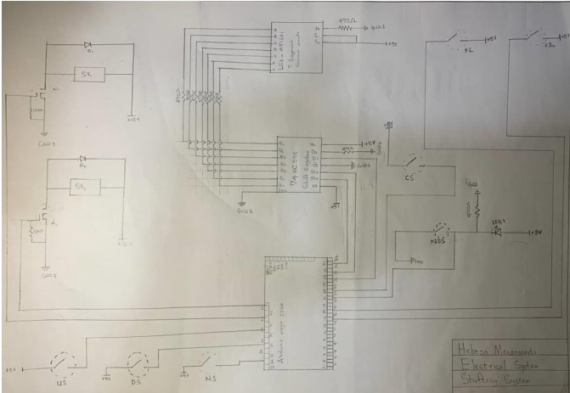

Figure : SHIFTING SYSTEM CIRCUITARY

Implementation

Challenges

## CONCLUSION AND FUTURE WORK

## APPENDIX

Wire diagram

Ecu programming

All code

More pictures